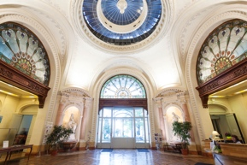
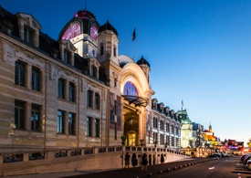

Accomodation Registration form for

Please, return this form by e-mail to :
commercial@evian-tourisme.com
no later than July 31, 2023

Company/Organization Name : _______________________________________________________
Address : ________________________________________________________________________
Zip/Postal : ____________ City : _________________________ Country : _________________
Last Name : ______________________________ First Name : _________________________
Accompanying person (Last name and first name): ________________________________________
Phone : _______________________ Mobile Phone : _____________________________________
Email : ___________________________________________________________________________

BOOKING :
All the hotels listed below are within walking distance of the venue (Palais Lumière).
The rates include breakfast and day taxes.

Arrival date : _____ / Sept / 2023 Departure date : _____ / Sept / 2023

Hotels | Selected order  (*) | Single room  (1 person,  1 large double bed) | Double room  (2 persons,  1 large double bed) | Twin room  (2 persons /2 large beds)
CONTINENTAL** |  | 85 € | 94 € | 94 €
FRANCE** |  | 85 € | 94 € | 94 €
ALIZE*** |  | 110 € | 122 € | 122 €
BOURGOGNE*** |  | 110 € | 122 € | 122 €
LITTORAL*** |  | 110 € | 122 € | 122 €
SAVOY*** |  | 110 € | 122 € | 122 €
ETHIC ETAPES  (Stay center) |  | 50 €  1 single bed | ////////// | 82 € 2 single beds  115 € 3 single beds

(*) Please, rate hotels from 1 (1st choice) to 3 (last choice): we will assign you the hotel in this order of preference. If the chosen hotel is full at the time of booking, the following hotel will be allocated to you.

Office de Tourisme et des Congrès d’Evian
B.P 18 - 74500 Evian
Etablissement Public Industriel et Commercial
Immatriculé au registre des opérateurs de voyages et de séjours IMO74100143
Garantie financière : GROUPAMA Assurance Crédit - 8/10 rue d’Astorg - 75008 PARIS
Assurance RC professionnelle : MMA IARD - 14 Bd Marie et Alexandre Oyon - 72000 Le Mans

TERMS OF PAYMENT :
Do not pay anythig before sending this registration form.

The reservation will be confirmed by the payment.
Please choose your mode of payment :

Bank check payable to Office de Tourisme d’Evian
Bank transfer
Credit Card (Only Visa or Mastercard, except American Express):
you can phone for your transaction to +33(0)4 50 75 40 68, or you can add the numbers :
Credit card number: ______ / ______ / ______ / ______
Expiration date: ____ / ____ Cryptogramm: ______

Upon receipt of your completed registration, we will send you an email with the amount of your reservation and the address of your hotel.

TERMS OF CANCELLATION :

Any request for cancellation or modification of dates must be made by letter or email to the Tourist Office of Evian (commercial@evian-tourisme.com).

In case of partial or total cancellation of the reservation before the beginning of the stay, it will be charged to costumer:
more than 20 days before the start of the stay : no charge
between the 20th and 8th day before the start of the stay : 50% of the reservation
less than 7 days (7th day being included) before the start of the stay: 100 % of the
reservation

Date : Signature :

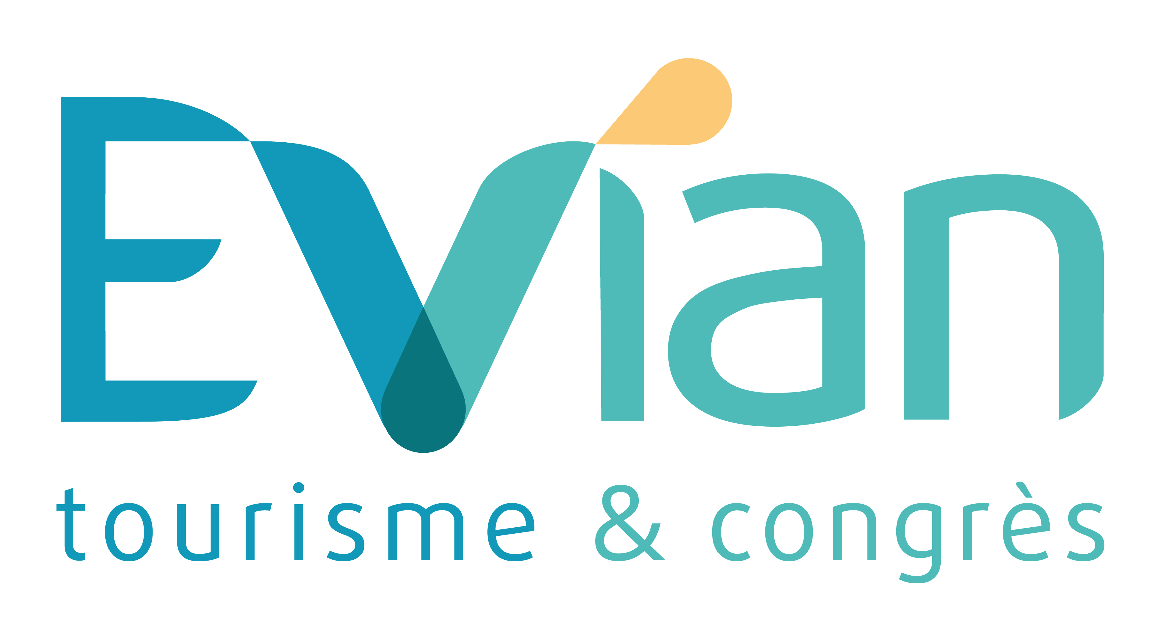

Office de Tourisme et des Congrès d’Evian
B.P 18 - 74500 Evian
Etablissement Public Industriel et Commercial
Immatriculé au registre des opérateurs de voyages et de séjours IMO74100143
Garantie financière : GROUPAMA Assurance Crédit - 8/10 rue d’Astorg - 75008 PARIS
Assurance RC professionnelle : MMA IARD - 14 Bd Marie et Alexandre Oyon - 72000 Le Mans

