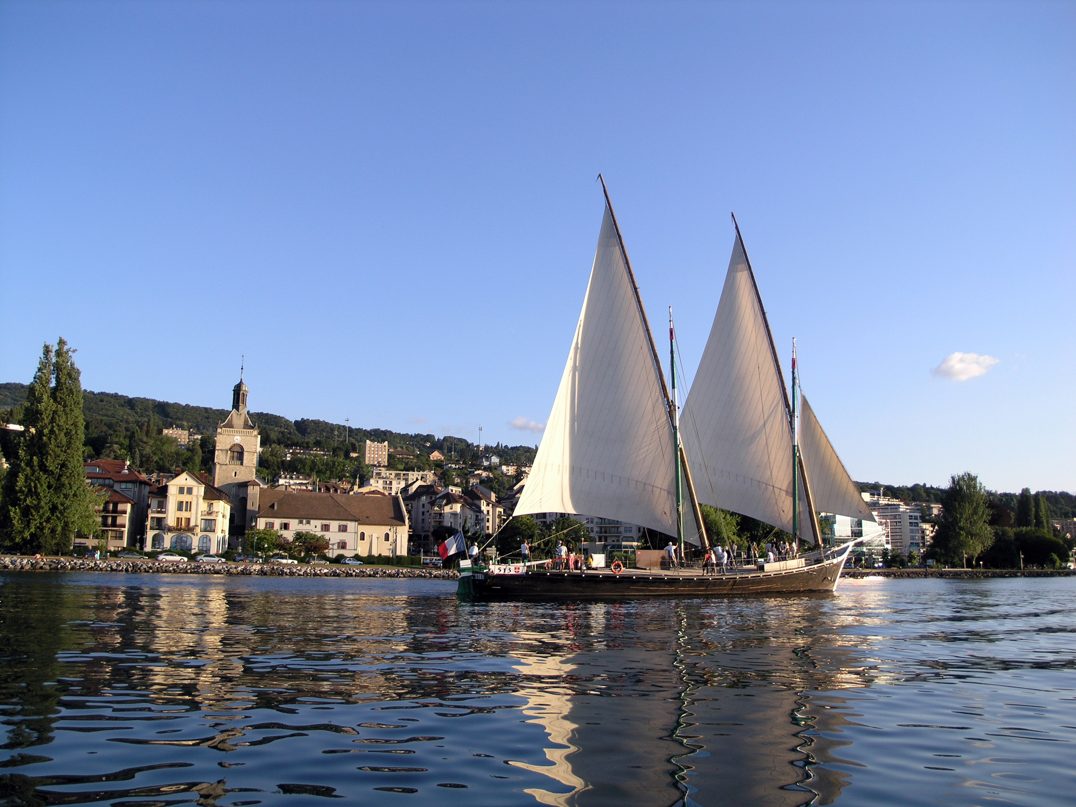
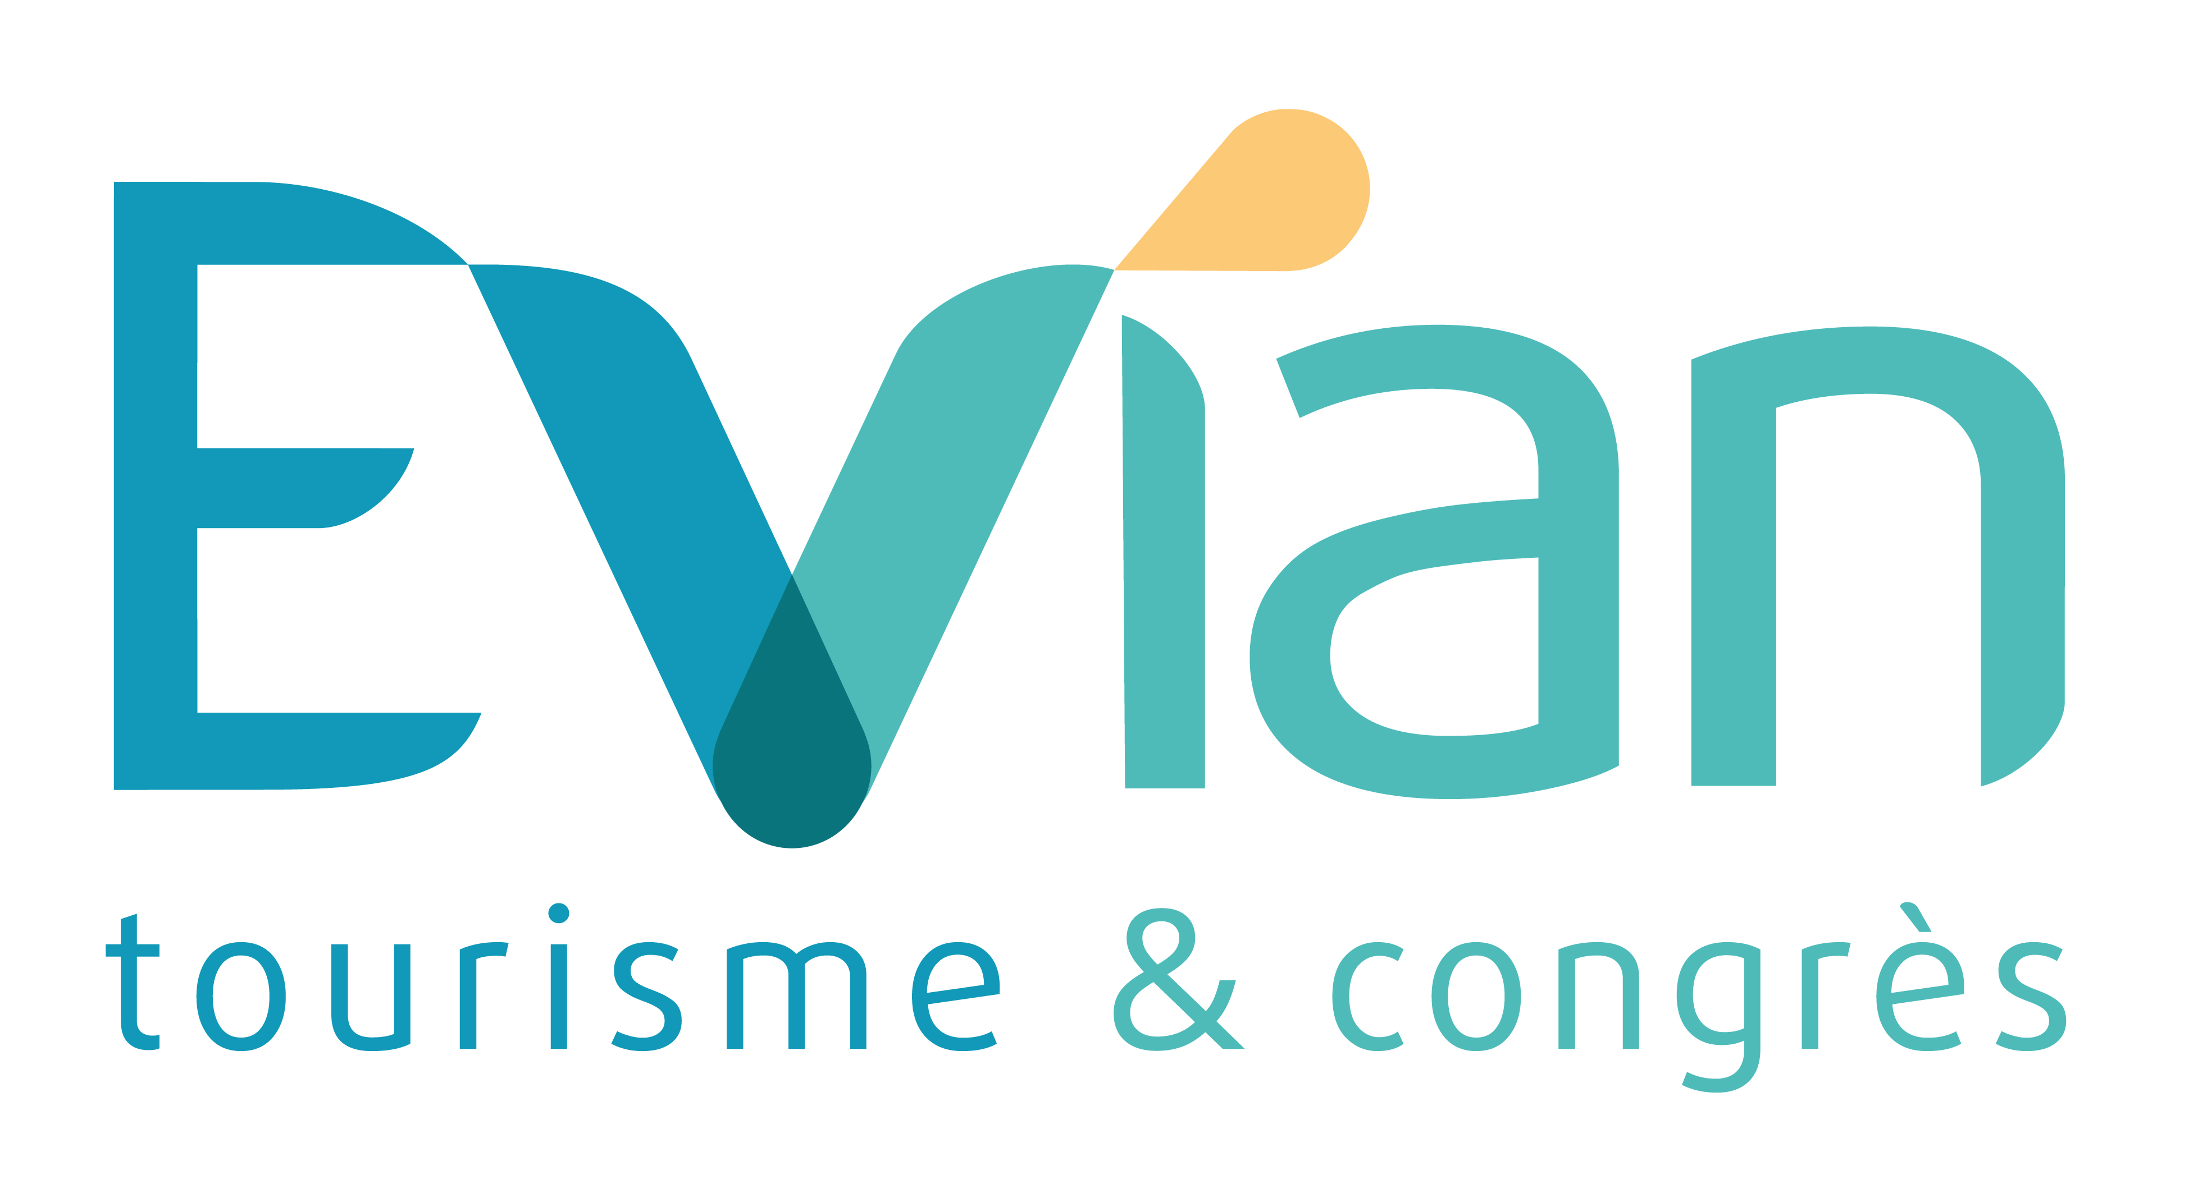

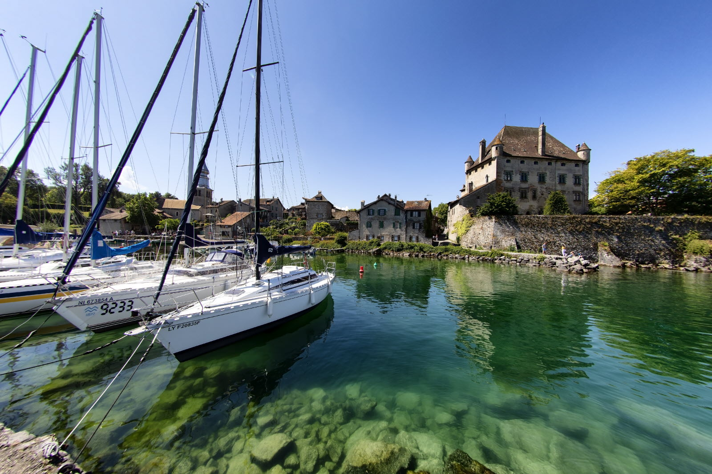

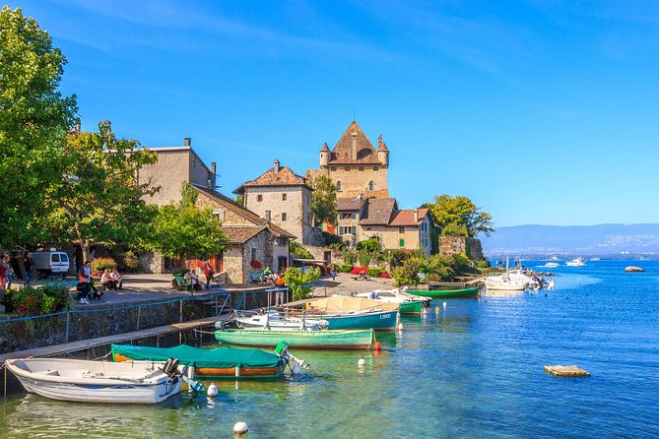
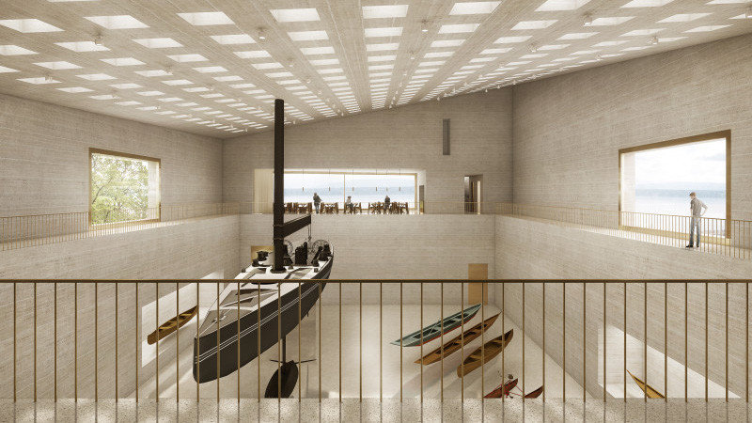

Registration form for suggestions of visits

Cruise: Wednesday 27, 2023: 25 €.
Cruise aboard The Savoie, the emblematic boat of Lake Geneva.
5:30pm - 6:30 pm.
Ideal to discover the navigation with latin sails
Appointment: 5:15 pm

Saturday 30, 2023: 2 possibilities of tours:

Option 1: 85 €.
The medieval village of Yvoire (France) and the Lake Geneva Museum in Nyons (Switzerland).
9:30am - 6:45pm
Appointment: 9.30 am in front of Palais Lumière
Guided tour of Yvoire
Lunch in a restaurant in the village
Transfer by boat to Nyons in Switzerland
Guided tour of the Lake Geneva Museum
Transfer by boat to Yvoire in France
Return by bus to Evian

Option 2: 62 €
The medieval village of Yvoire
9:30am – 6:45 pm
Appointment: 9.30am in front of Palais Lumière
Guided tour of Yvoire
Lunch in a restaurant in the village
Free time in Yvoire
Return by bus to Evian

Please, return this form by e-mail to commercial@evian-tourisme.com
no later than September 1st, 2023

Company/Organization Name : …………………………………………………………………………………
Address : ………………………………………………………………………………………………………….
Zip/Postal : ……………… City : …………………………………… Country : ……………………….
Last Name : ………………………………………….. First Name : ……………………………………..
Mobile Phone : ………………………………………. Email : ……………………………………………

BOOKING :

Price of Cruise: 25 € per person / Number of persons: ________

Price of Option 1: 85 € per person / Number of persons: ________

Price of Option 2: 62 € per person / Number of persons: ________

TOTAL AMOUNT OF THE RESERVATION: ________ €

TERMS OF PAYMENT :
Do not pay anything before sending this registration form.

The reservation will be confirmed by the payment. Please choose your mode of payment:

Bank check payable to Office de Tourisme d’Evian

Bank transfert

Credit Card (Visa, Master Card, etc EXCEPT American Express):

Credit card number : ______ / ______ / ______ / ______

Expiration date: ____ / ____ Security Code : ______

Upon receipt of your registration, we will send you a confirmation email with the amount of your reservation.

TERMS OF CANCELLATION :
Any request for cancellation or modification must be made by letter or e-mail to the Tourist Office of Evian no later than September, 10, 2023.

Date : Signature :

EVIAN TOURISME ET CONGRES
Place d’Allinges74500 EVIAN CEDEX
+33(0)4 50 75 04 26 - commercial@evian-tourisme.com - www.evian-tourisme.com

